Project Communication
- Definition and Importance
- Cultural issues
- Communication Requirements Analysis
- Types of communication
- Communication Plan

Communication
Throughout the project a need to communicate to
- Project Sponsor
- Team members
- Other stakeholders
  - Customers
  - Clients
  - Suppliers
  - Partners
  - The public

For each group
- Purpose
- Frequency
- Format
- Amount of time
- Possible need for a hierarchy of reporting:
  - Portfolio
  - Program
  - Project
  - Task group

Synchronous Options
- Face to face
- Synchronous but not in the same place– (remember the time zones!)
  - Conference call
  - Video link
  - Computer-assisted video conference
  - IM; texting

Asynchronous Options
- Courier, mail
- E-mail
- Fax
- Project Blog
- RSS
- Social media presence

Communication Planning
- Who?
- Why?
- What do they need/want to know? Or communicate to the project?
- When? How frequently?
- How? (what method(s) do they prefer? Are there methods that are unsuitable?
- Who will be the contact point from the project for this communication?

Team Meetings
- Purpose is to verify progress, identify challenges and get assistance where needed.
- Frequency and duration may vary throughout the project
- Be considerate and schedule “off-line” meetings if only a few are involved in a particular item. It wastes the time of the rest.
- Frequent very short meetings may be more effective with a small team (daily “stand-up” meetings are a standard part of Agile Systems Development.)
- PM may need to meet and report with other PMs in the same program or portfolio.

Report to Management or Sponsor
- Frequency and format may be dictated by Sponsor
- Purpose to report progress, identify challenges and changes, get support for necessary changes or added resources
- Need balance between “raising the alarm” too early and waiting too long and being “in too deep”

Other stakeholders
- The community may need to be consulted and informed—about the Riverview Lands project in Coquitlam.
- Business customers or suppliers may be impacted by the project.
- The project contractor/supplier needs to know about other aspects of the project and inform the PM of the status.
- The government may have a role—permits, inspections, other
- The Project Management Office
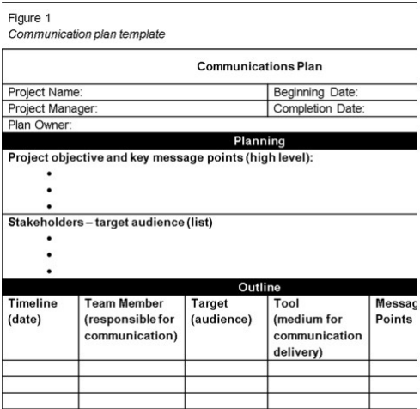
- The frequency, format and content of communications may be dictated by law or may be a provision of a contractual agreement.

Communication Plan Template

Summary
- Project Communication
- Project communication is a key success factor
- Start with a Communication Requirements Analysis and then Prepare a Communication Plan that considers all the stakeholders
- Consider a variety of synchronous and asynchronous methods
- Use appropriate technology
- Consider cultural issues when planning and carrying out project communication
- Remember communication is a two-way process, not always “broadcast!”

